Project 2: Further Exploration of PPI
An unsolved question in the assignment is whether two proteins share similar cohorts of neighbouring proteins are likely to have functional similarity. Our group aims to further explore the question in several dimensions.
To begin with, the question actually has a straightforward solution: we can interrogate all proteins in the network, asking about their neighbour similarity (DC distance) and functional similarity. Thus, we can calculate to what extent this holds true to the protein-protein interaction network. This gives us an overview of the question.
Then, the questions here are how we define functional similarity. A simple way to define this is by comparing Gene Ontology annotations. So, we may annotate the network with GO terms and compare functional similarity. One thing we are investigating now is how the functional similarity drives PPI evolution. Thus, I will argue to annotate the network with the evolutionary history profiles. Thus, we can explore how the similarity varies in networks with different evolutionary profiles. To construct a network with annotated evolutionary history, we need to use at least two different networks, one from yeast and the other from human, to indicate what proteins are lost, gained, or conserved during evolution.
During evolution, there are two major changes that might take place. First, functional turnover, which in our context, can be defined as the proportion of the neighbours lost or gained. Second, expression turnover, which can be acquired from protein database. We will then visualise how these events happen in proteins with different evolutionary history profiles.
We refer to a similar work on genetic interaction (https://www.nature.com/articles/s41467-019-11735-3). Thus, it is likely that protein expression turnover might drives conservation or discontinuation of protein-protein interaction. My guess is that those with increased expression levels will attract more neighbouring proteins during evolution. Thus, functional turnover is linked to expression turnover.
However, what is not known is how frequently this happens and what is difference for conserved and non-conserved proteins. So, we are interested in how likely other proteins are to interact with conserved proteins with increased or decreased expression. We can here visualise how expression is associated with attachment of non-conserved proteins and with attachment/detachment of conserved proteins. Also we can visualise how de novo interaction is associated with centrality and expression levels. Finally, we may predict the conservation or discontinuation of interaction with the two parameters or more metrics.
we refer to an earlier work on how inclusion of evolutionary history improves PPI prediction based on similarity metrics (https://journals.plos.org/plosone/article?id=10.1371/journal.pone.0183495). This suggests that evolutionary history is important to accurate prediction of protein function. Back to our original question, we will argue that if a protein frequently changes its neighbouring proteins during evolution, it is unlikely to share the same function despite high CD similarity. Our study will help explain how this kind of turnover happens and how common it is, which together explains the original question.

Visualisation of protein interaction network (this is a bit useless but we can explain what this network is like)
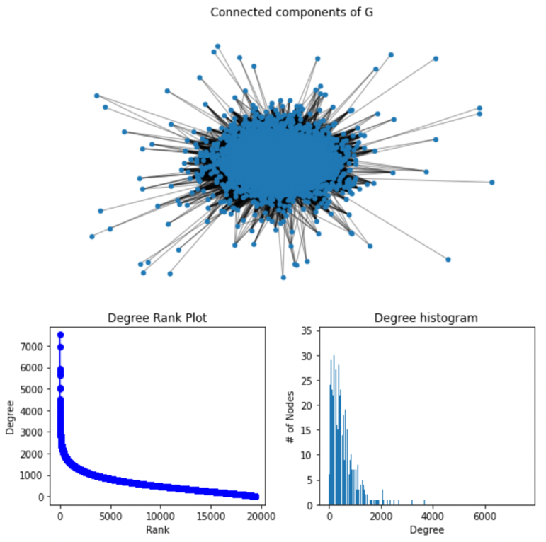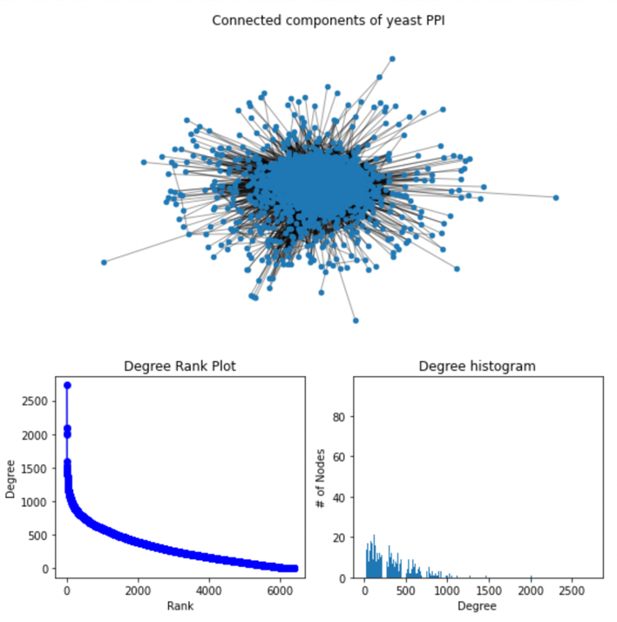
Evolutionary history types (which suggests overall protein conservation)
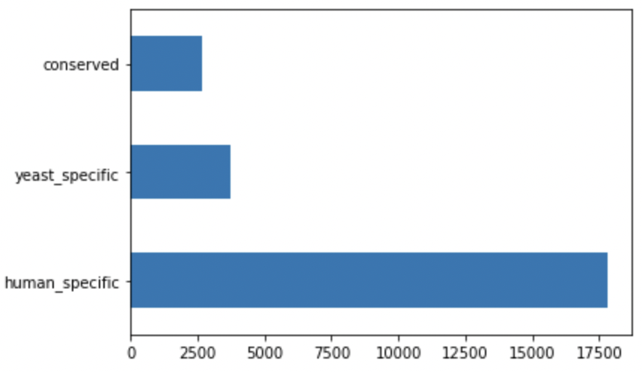

The results indicate a versatile nature of protein function with only a few proteins considered to be conserved (not sure why this is the case, but I will check about it later…) I will also try to annotate the evolutionary distance later, as I am not sure how to do that right now…
I will check this with Wilson or consult more papers later. But this would not be a big issue, as only the column value will be changed and the column itself stands. Whereas possible, I will also check the PPI of mouse.

Please ensure the scalability of your code, since parameters such as evolutionary distance, sequence similarity will be added later, so you may have a chance to reuse your code.
Also I have set up a shared folder at https://drive.google.com/drive/folders/1IonMHckfb49NJNq8Y4vNDfNWTW2vJS1C?usp=sharing
where you can share your file and download what I have got.
Gene set enrichment results of different evolutionary type (which suggests difference in functionality conservation)
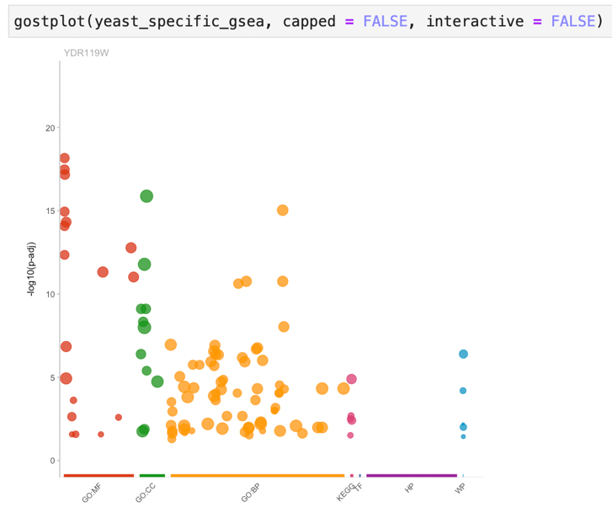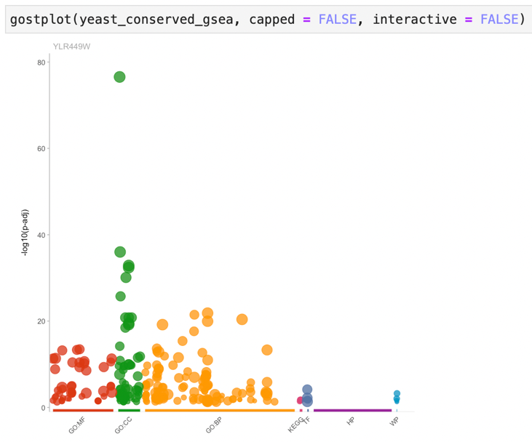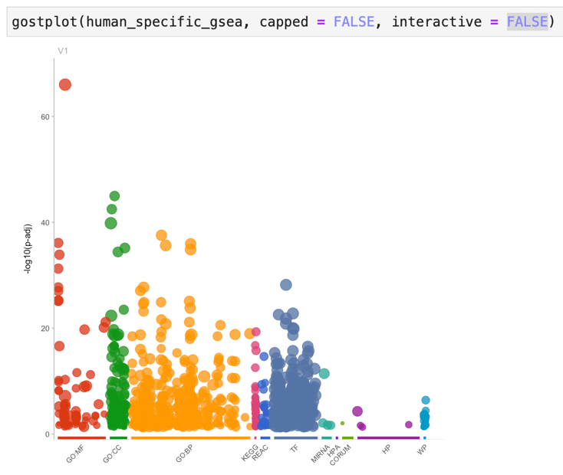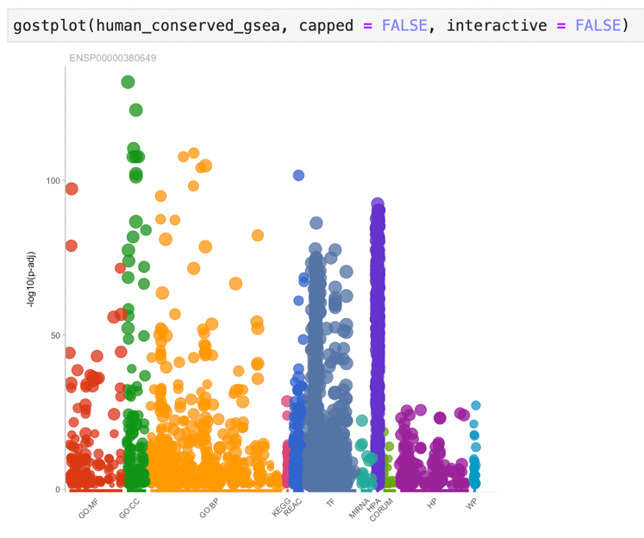
So the result here show distinct enrichment patterns across different evolutionary types in two species. (For Wan Yon)
- Here we need Venn plots to illustrate how function overlap between different evolutionary categories. Just all pairs please. We will see then.
- To visualise how conserved proteins function may evolve and how different lineage-specific proteins are assigned to different biological functions, is it possible to use parallel coordinates chart.
  - A possible coordinate should start from biological functions and then yeast protein linked to that function and then human protein linked to that.
  - Another plot should use conserved proteins as a coordinate to indicate how they give rise to new biological functions during evolution.
- Additionally, there is a density plots to be plotted in the Jupyter Notebook. Please read the notebook for more detail.
Note that evolution does not necessarily imply functional similarity, but just similarity. We are interested in the probabability of each edge to continue or dissolve during evolution, especially:
- Whether this is significantly impacted by certain network related metrics (especially shared number of neighbours, indicated by CD distance) and how can network-related metrics improve our prediction of continuation/discontinuation states of protein-protein interaction.
For this part we need people to (For Siqi):
- Calculate centrality, degree (I have written code about this) and you may want to calculate more metrics (please read metrics available at https://networkx.org/documentation/networkx-1.10/reference/algorithms.html for more help) and networkx package allows this as you like
- Visualise correlation, patterns or clustering of proteins of different evolutionary profiles if there is any
- try different model for prediction of evolutionary types, starting from decision tree, naïve Bayes, etc, as long as you find a propoer one…

The possible states for each edge during evolution (consider the network a directed graph and if not you can simplify this a bit):
- Conserved protein1, conserved protein2
- Conserved protein1, changed protein2
- Changed protein1, conserved protein2
- Changed protein1, changed protein2
We want to find out whether there are patterns of the conservation related network metrics or other available metrics and whether we can predict this change.

- Also, we aim to describe the popularity of the interactions continuation or discontinuation and whether the percentage of changed interaction of each node or each functional modules can be described or predicted with network/evolution-related metrics. (For Yifan)
- We may calculate the evolutionary change rate (ECR) in a similar way of CD distance adjustment (shown below), but I don’t know whether this is a good-enough approach for each node
$$ECR= \frac{n_{conserved protein}}{max(0, \overline{degree}-degree) + degree}$$
  - We may also calculate the evolutionary change rate in a simple way.
$$Simple ECR= \frac{n_{conserved protein} }{degree}$$
Then we can apply this to an edge the similar way. Maybe should calculate both to see which is better…Or maybe you have a better idea of scoring…
- Use a pairplot to see how ECR is affected by other paramters, including between centrality, CD distance, etc, and visualise possible correlation. You may further investigate the data if you find anything interesting
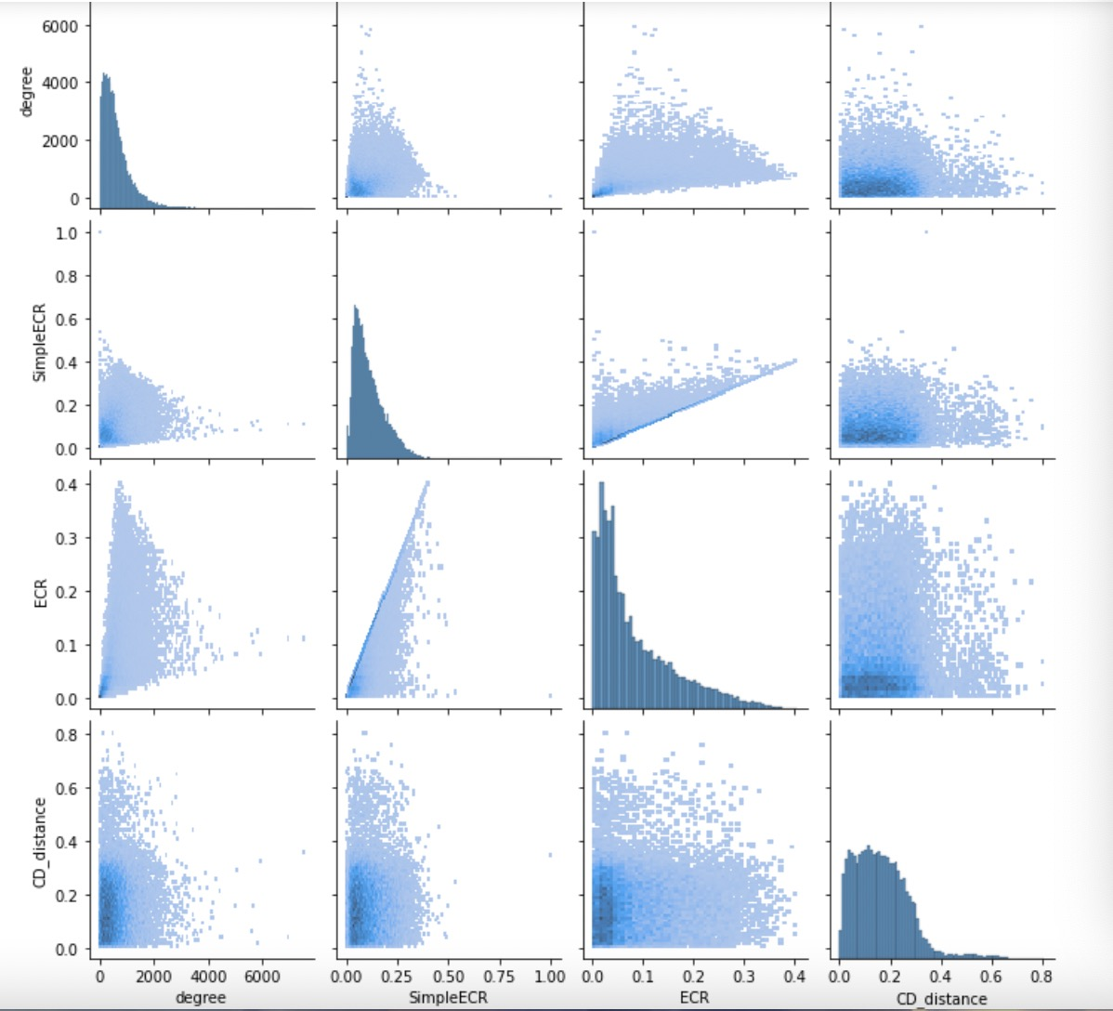

- 按照这篇文章（https://journals.plos.org/plosone/article?id=10.1371/journal.pone.0171920），我们差不多可以结束了，代码给我，我改改图，按照这篇文章的格式写一下论文。
- 我认为其中缺了什么呢？第一是missing protein interaction，可以按照（https://journals.plos.org/plosone/article?id=10.1371/journal.pone.0177029#sec012）来做，
- 第二是没做interactomes simultation、phylogeny以及clustering，可以继续做一下。


 